**DSA PRACTICE**

**(NOVEMBER 14, 2024)**

**1.Stock buy and sell :**

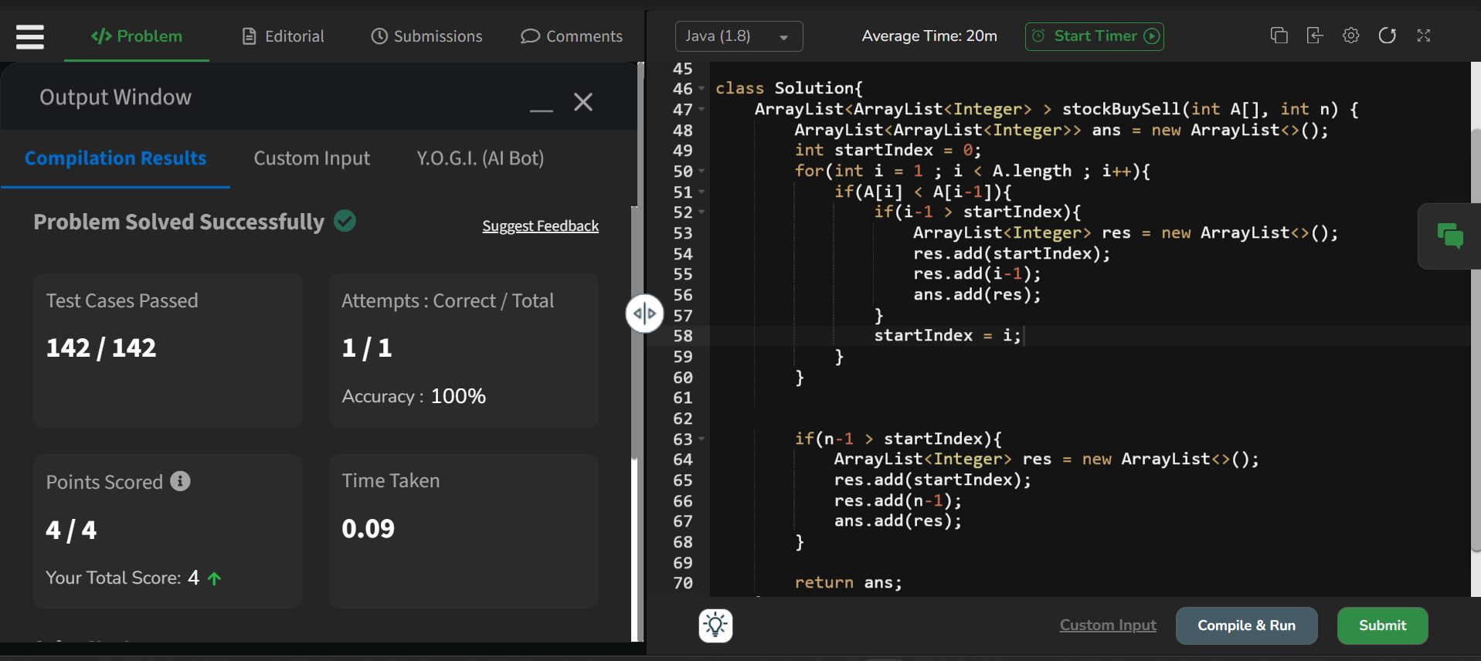

Time Complexity : O(N)

Space Complexity : O(N)

**2. Coin exchange**

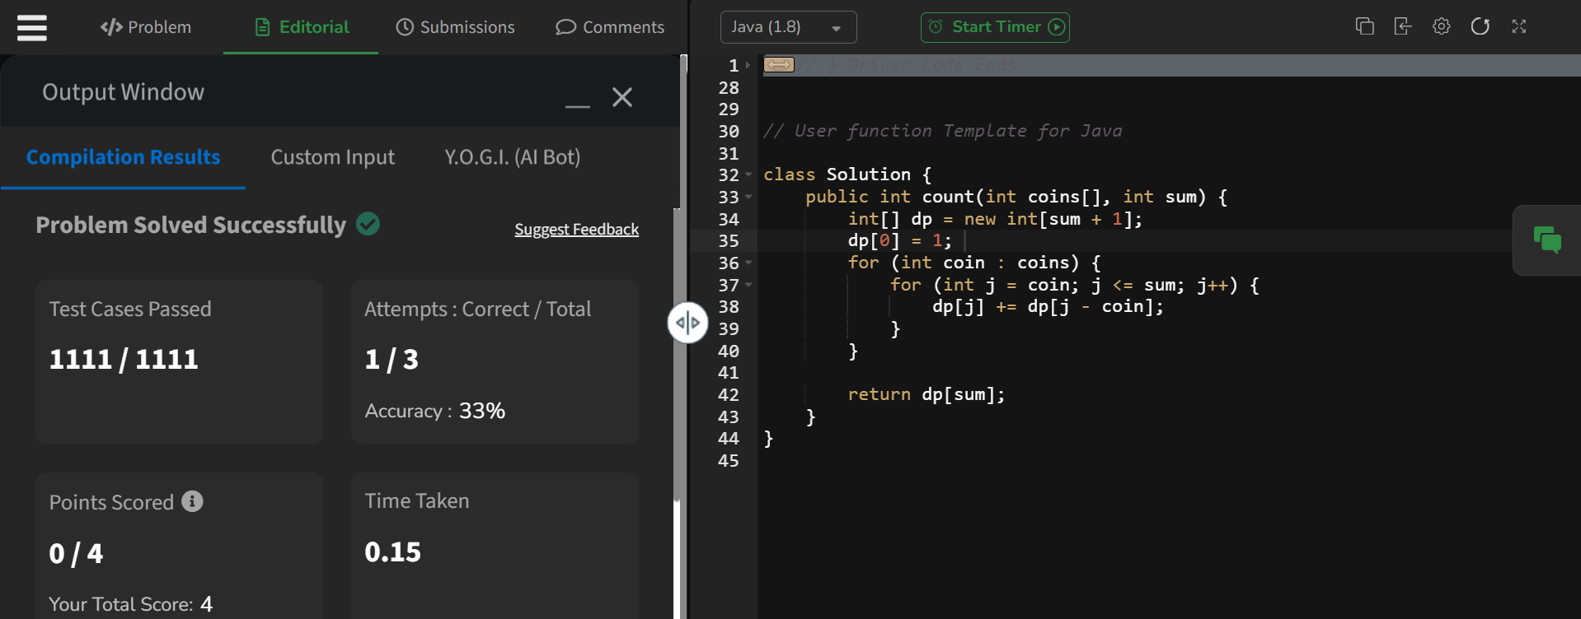

Time Complexity : O(N*M)

Space Complexity: O(M)

**3. First and last occurrence   
  
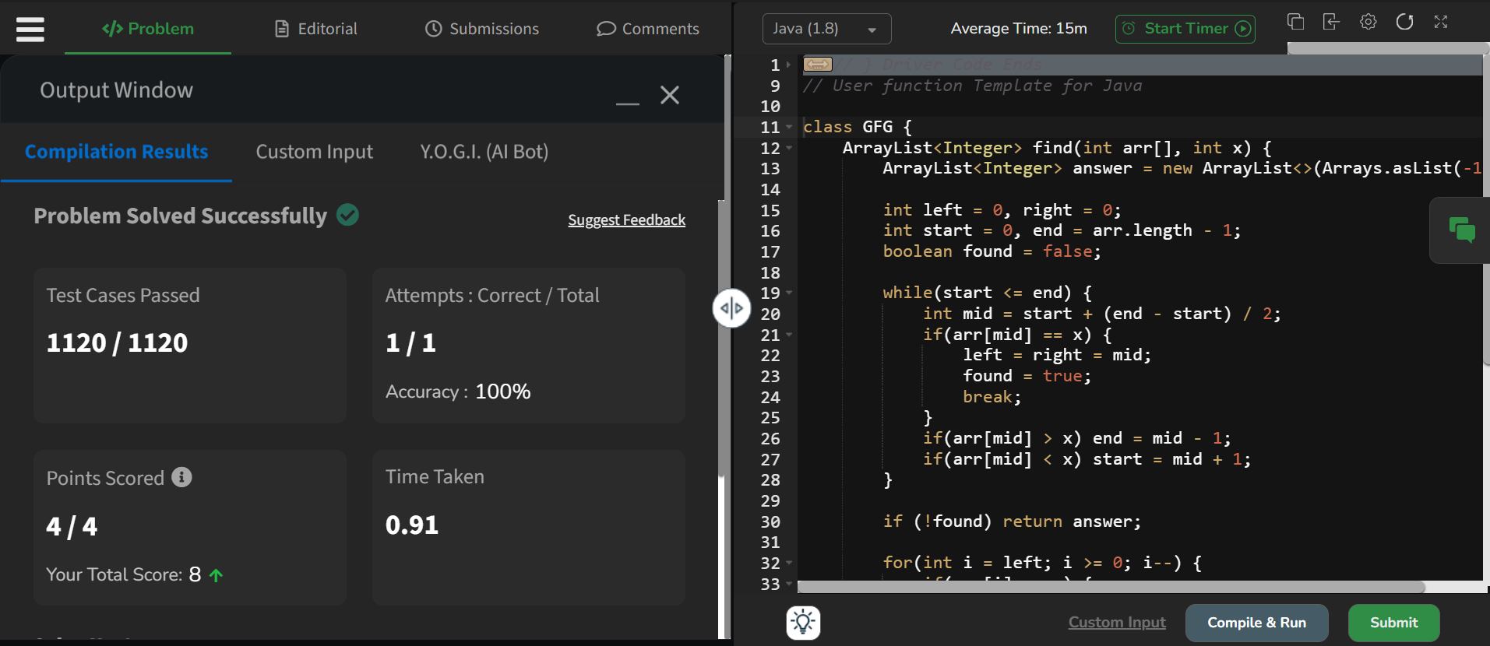**

Time Complexity : O(N)

Space Complexity : O(1)

**4. First Index Transition**

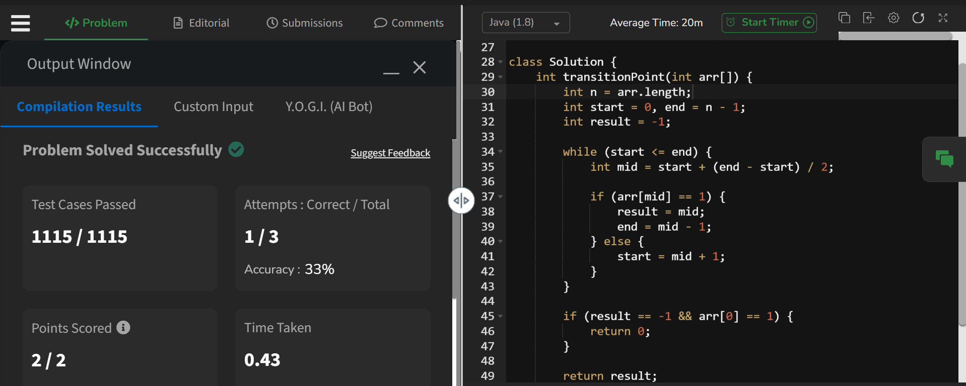

Time Complexity : O(log n)

Space Complexity : O(1)

**5. First Repeating String   
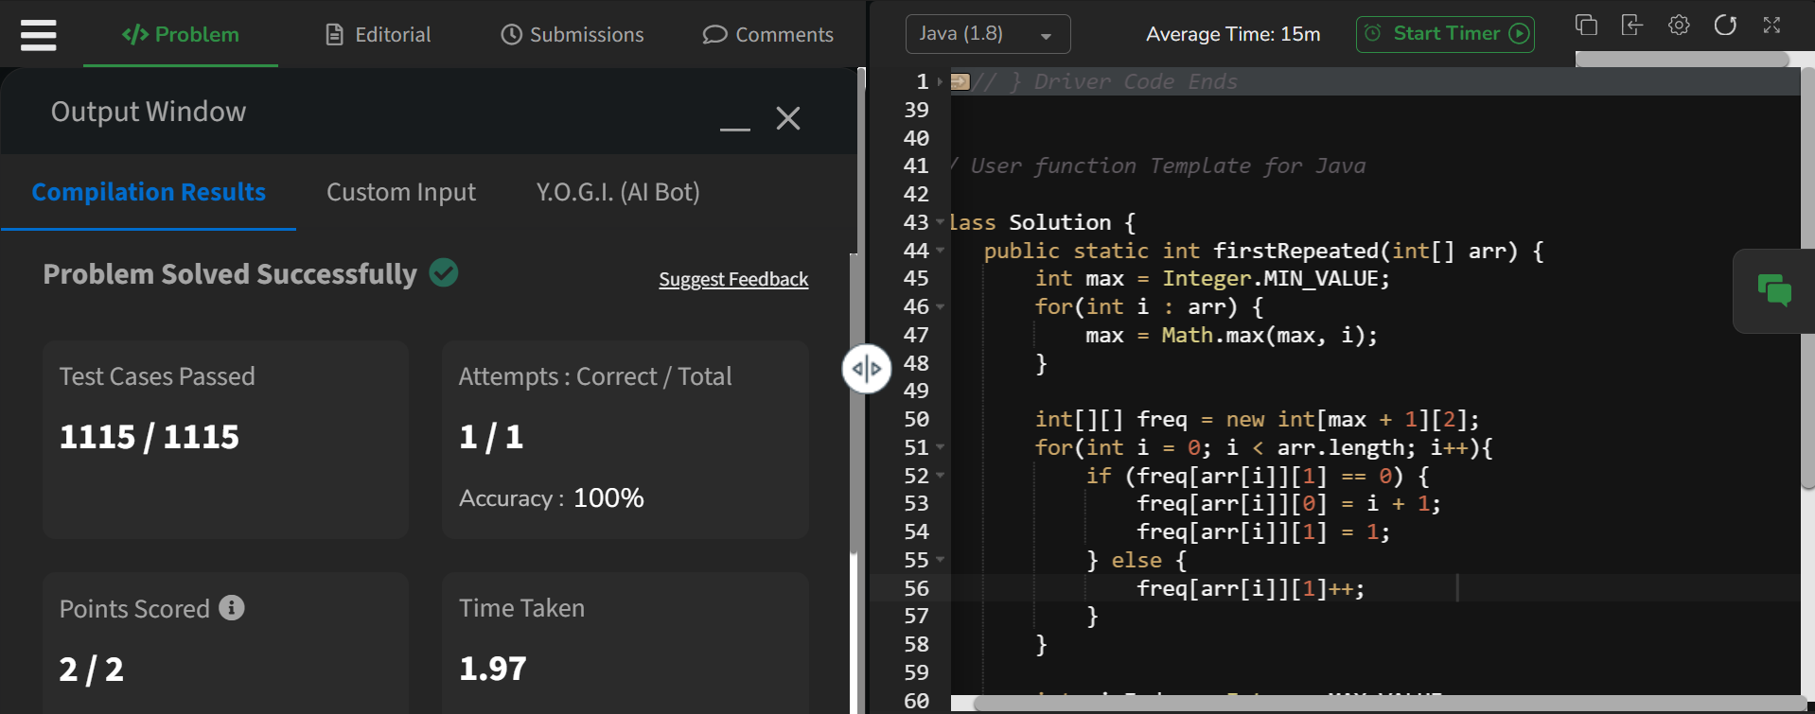**

Time complexity: O(N)

Space Complexity: O(M)

**6. Remove Duplicates from the List  
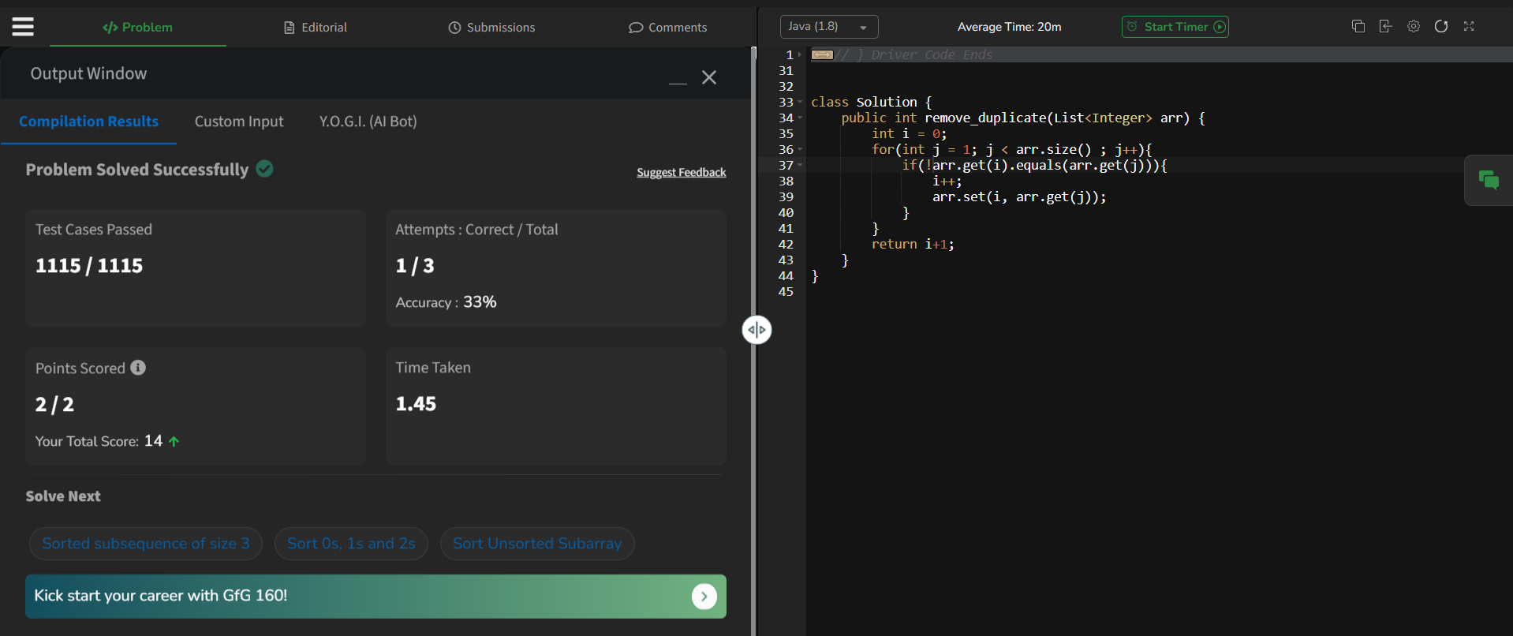**

Time Complexity : O(N)

Space Complexity : O(1)

**7. Maximum Index**

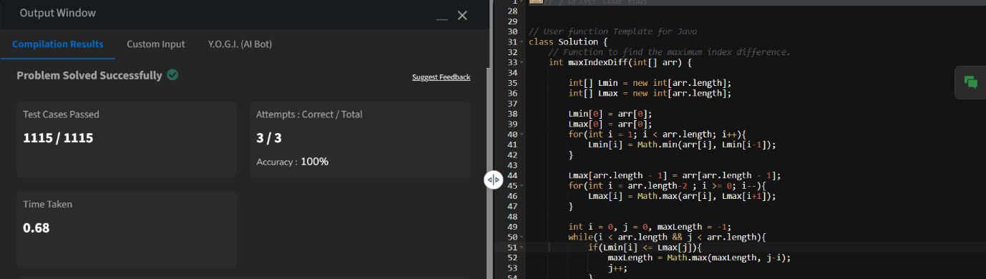Time Complexity : O(N)

Space Complexity : O(N)

**8. Wave Array**

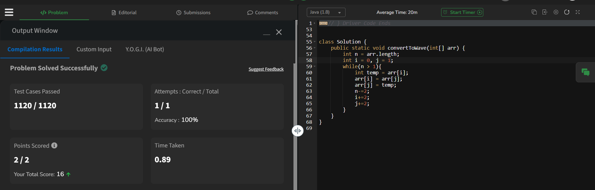

Time Complexity : O(N)

Space Complexity : O(1)